without adv

data not rebalanced

training 1 epoch...

1609.1408731937408 seconds used......

1 training finished! average train loss: 0.5076565624649326

evaluating...

Confusion matrix, without normalization

[[ 187 428 13 361]

[ 42 5095 24 288]

[ 3 162 1350 1287]

[ 28 294 734 9703]]

Normalized confusion matrix

[[0.18907988 0.43276036 0.01314459 0.36501517]

[0.00770784 0.93503395 0.00440448 0.05285373]

[0.00107066 0.05781585 0.48179872 0.45931478]

[0.00260247 0.02732596 0.06822195 0.90184961]]

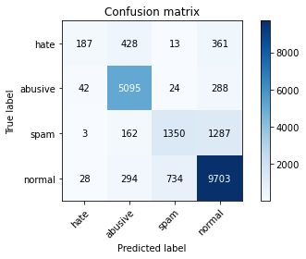

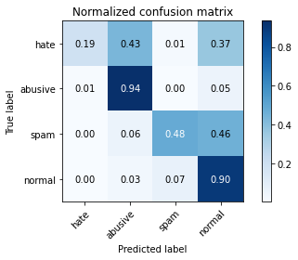

precision recall f1-score support

hate 0.72 0.19 0.30 989

abusive 0.85 0.94 0.89 5449

spam 0.64 0.48 0.55 2802

normal 0.83 0.90 0.87 10759

accuracy 0.82 19999

macro avg 0.76 0.63 0.65 19999

weighted avg 0.81 0.82 0.80 19999

average eval_loss: 0.47648587604612114, accuracy: 0.8167908395419771

training 2 epoch...

1609.6934399604797 seconds used......

2 training finished! average train loss: 0.42495992831637464

evaluating...

Confusion matrix, without normalization

[[ 207 458 15 309]

[ 43 5142 20 244]

[ 3 180 1515 1104]

[ 80 336 967 9376]]

Normalized confusion matrix

[[0.20930233 0.46309403 0.01516684 0.3124368 ]

[0.00789136 0.94365939 0.0036704 0.04477886]

[0.00107066 0.06423983 0.54068522 0.39400428]

[0.00743564 0.03122967 0.08987824 0.87145646]]

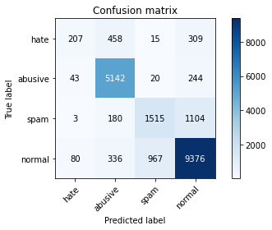

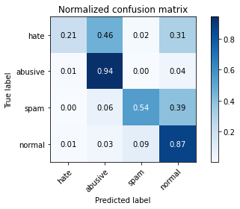

precision recall f1-score support

hate 0.62 0.21 0.31 989

abusive 0.84 0.94 0.89 5449

spam 0.60 0.54 0.57 2802

normal 0.85 0.87 0.86 10759

accuracy 0.81 19999

macro avg 0.73 0.64 0.66 19999

weighted avg 0.80 0.81 0.80 19999

average eval_loss: 0.48715847240388394, accuracy: 0.8120406020301015

training 3 epoch...

1608.525629043579 seconds used......

3 training finished! average train loss: 0.33584570279096565

evaluating...

Confusion matrix, without normalization

[[ 406 312 15 256]

[ 243 4956 35 215]

[ 15 171 1384 1232]

[ 257 364 895 9243]]

Normalized confusion matrix

[[0.41051567 0.31547017 0.01516684 0.25884732]

[0.04459534 0.90952468 0.0064232 0.03945678]

[0.00535332 0.06102784 0.49393291 0.43968594]

[0.02388698 0.03383214 0.08318617 0.85909471]]

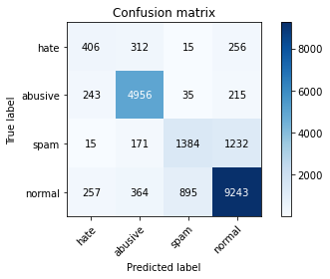

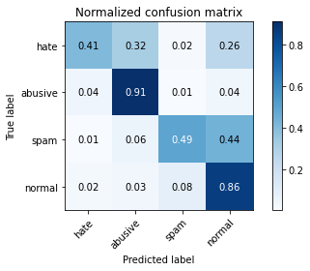

precision recall f1-score support

hate 0.44 0.41 0.43 989

abusive 0.85 0.91 0.88 5449

spam 0.59 0.49 0.54 2802

normal 0.84 0.86 0.85 10759

accuracy 0.80 19999

macro avg 0.68 0.67 0.67 19999

weighted avg 0.79 0.80 0.79 19999

average eval_loss: 0.5516862423792481, accuracy: 0.7994899744987249

training 4 epoch...

1608.5754144191742 seconds used......

4 training finished! average train loss: 0.2349574981375287

evaluating...

Confusion matrix, without normalization

[[ 233 455 16 285]

[ 58 5129 61 201]

[ 5 165 1267 1365]

[ 115 457 901 9286]]

Normalized confusion matrix

[[0.23559151 0.46006067 0.01617796 0.28816987]

[0.01064415 0.94127363 0.01119471 0.0368875 ]

[0.00178444 0.05888651 0.45217702 0.48715203]

[0.01068873 0.04247607 0.08374384 0.86309137]]

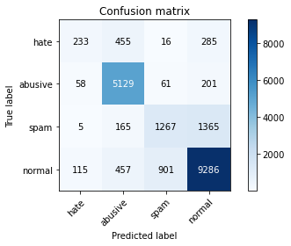

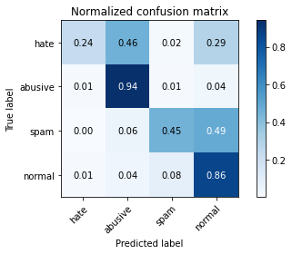

precision recall f1-score support

hate 0.57 0.24 0.33 989

abusive 0.83 0.94 0.88 5449

spam 0.56 0.45 0.50 2802

normal 0.83 0.86 0.85 10759

accuracy 0.80 19999

macro avg 0.70 0.62 0.64 19999

weighted avg 0.78 0.80 0.78 19999

average eval_loss: 0.65726547813043, accuracy: 0.7957897894894744

training 5 epoch...

1609.6290292739868 seconds used......

5 training finished! average train loss: 0.16883926188402498

evaluating...

Confusion matrix, without normalization

[[ 319 359 24 287]

[ 174 4880 154 241]

[ 5 141 1552 1104]

[ 123 374 1298 8964]]

Normalized confusion matrix

[[0.32254803 0.36299292 0.02426694 0.29019211]

[0.03193246 0.89557717 0.02826207 0.0442283 ]

[0.00178444 0.0503212 0.55389008 0.39400428]

[0.01143229 0.03476159 0.12064318 0.83316293]]

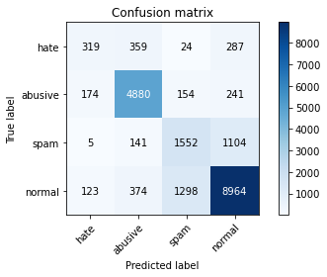

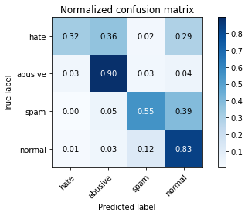

precision recall f1-score support

hate 0.51 0.32 0.40 989

abusive 0.85 0.90 0.87 5449

spam 0.51 0.55 0.53 2802

normal 0.85 0.83 0.84 10759

accuracy 0.79 19999

macro avg 0.68 0.65 0.66 19999

weighted avg 0.78 0.79 0.78 19999

average eval_loss: 0.8227336206659674, accuracy: 0.7857892894644732

training 6 epoch...